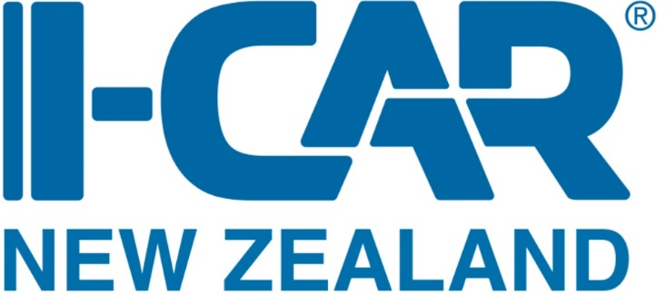

User guide for completing online courses through myI-CAR

Your Online Courses will be listed on your Dashboard as shown in the photo below. If you are accessing the course for the first time, click on Start Course.

If you have already started the course and are returning to it, click on Resume Course.
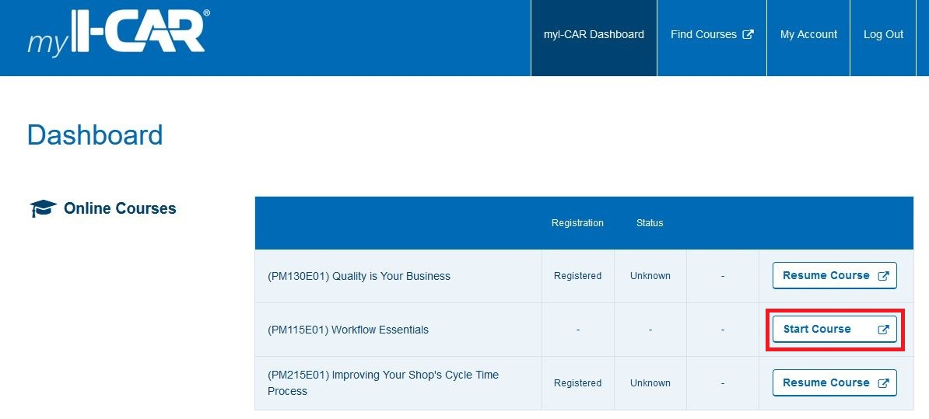

The image below is a reference guide for the menu functions in these courses.

To move through the presentation use the navigation arrows as shown on image below.
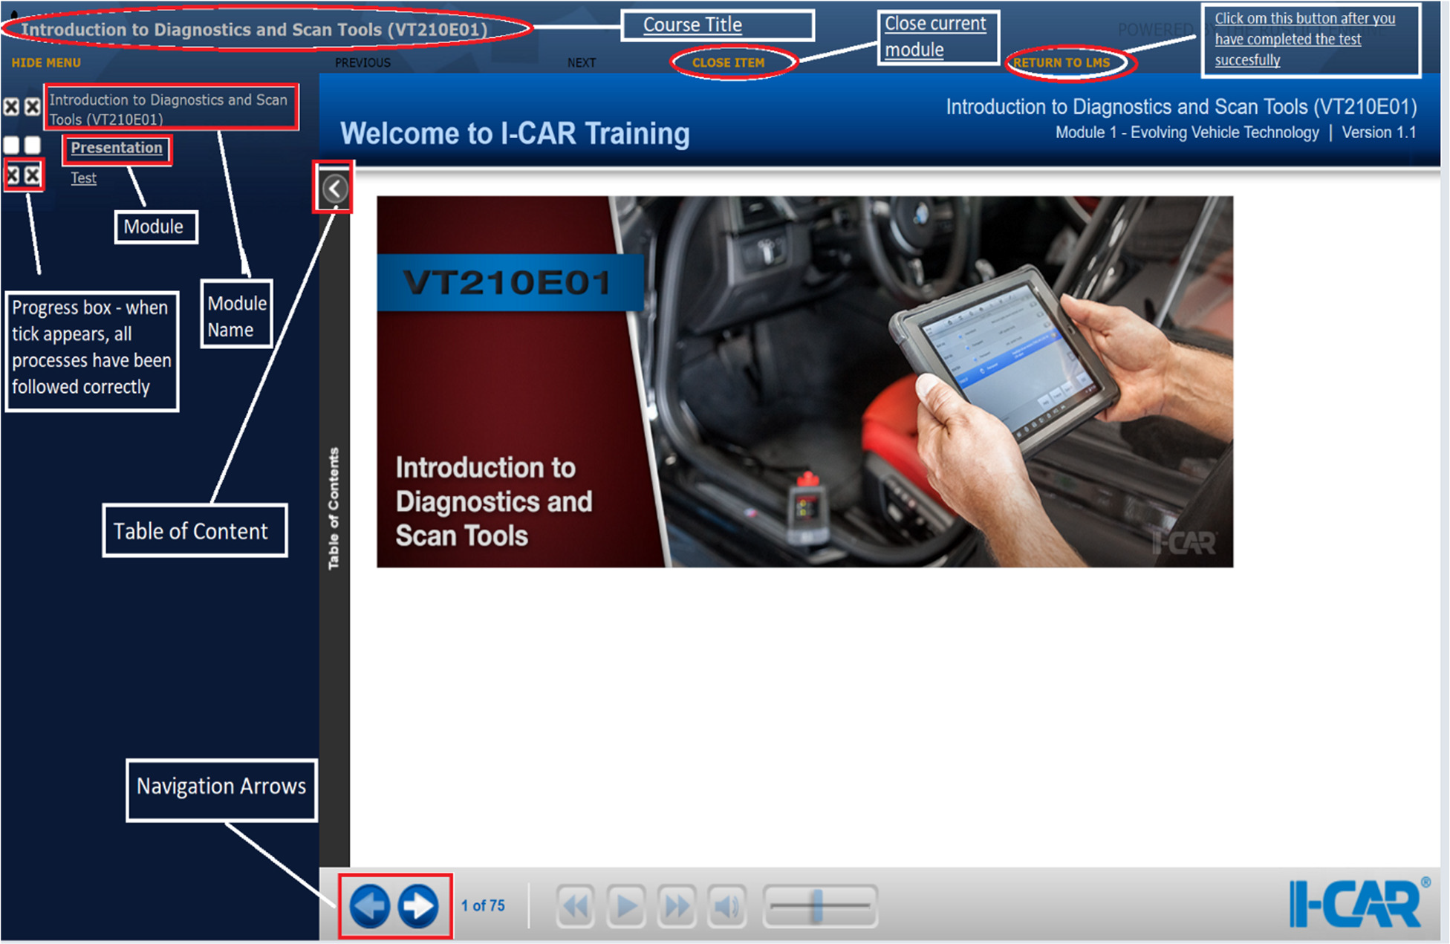

It is a requirement that all slides need to be viewed in order to complete the course.
Once all slides have been viewed the module called Presentation will be ticked off as complete. You can now move on to the next module by clicking on the Test key button.
While taking the test, in order to proceed to the next question, click on the Next button (highlighted in red below).
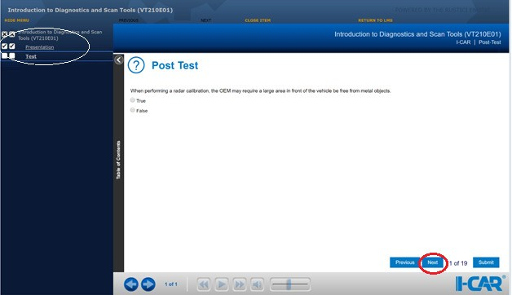
When all questions are completed click on Submit.
A results page will appear with the test summary/score/status.
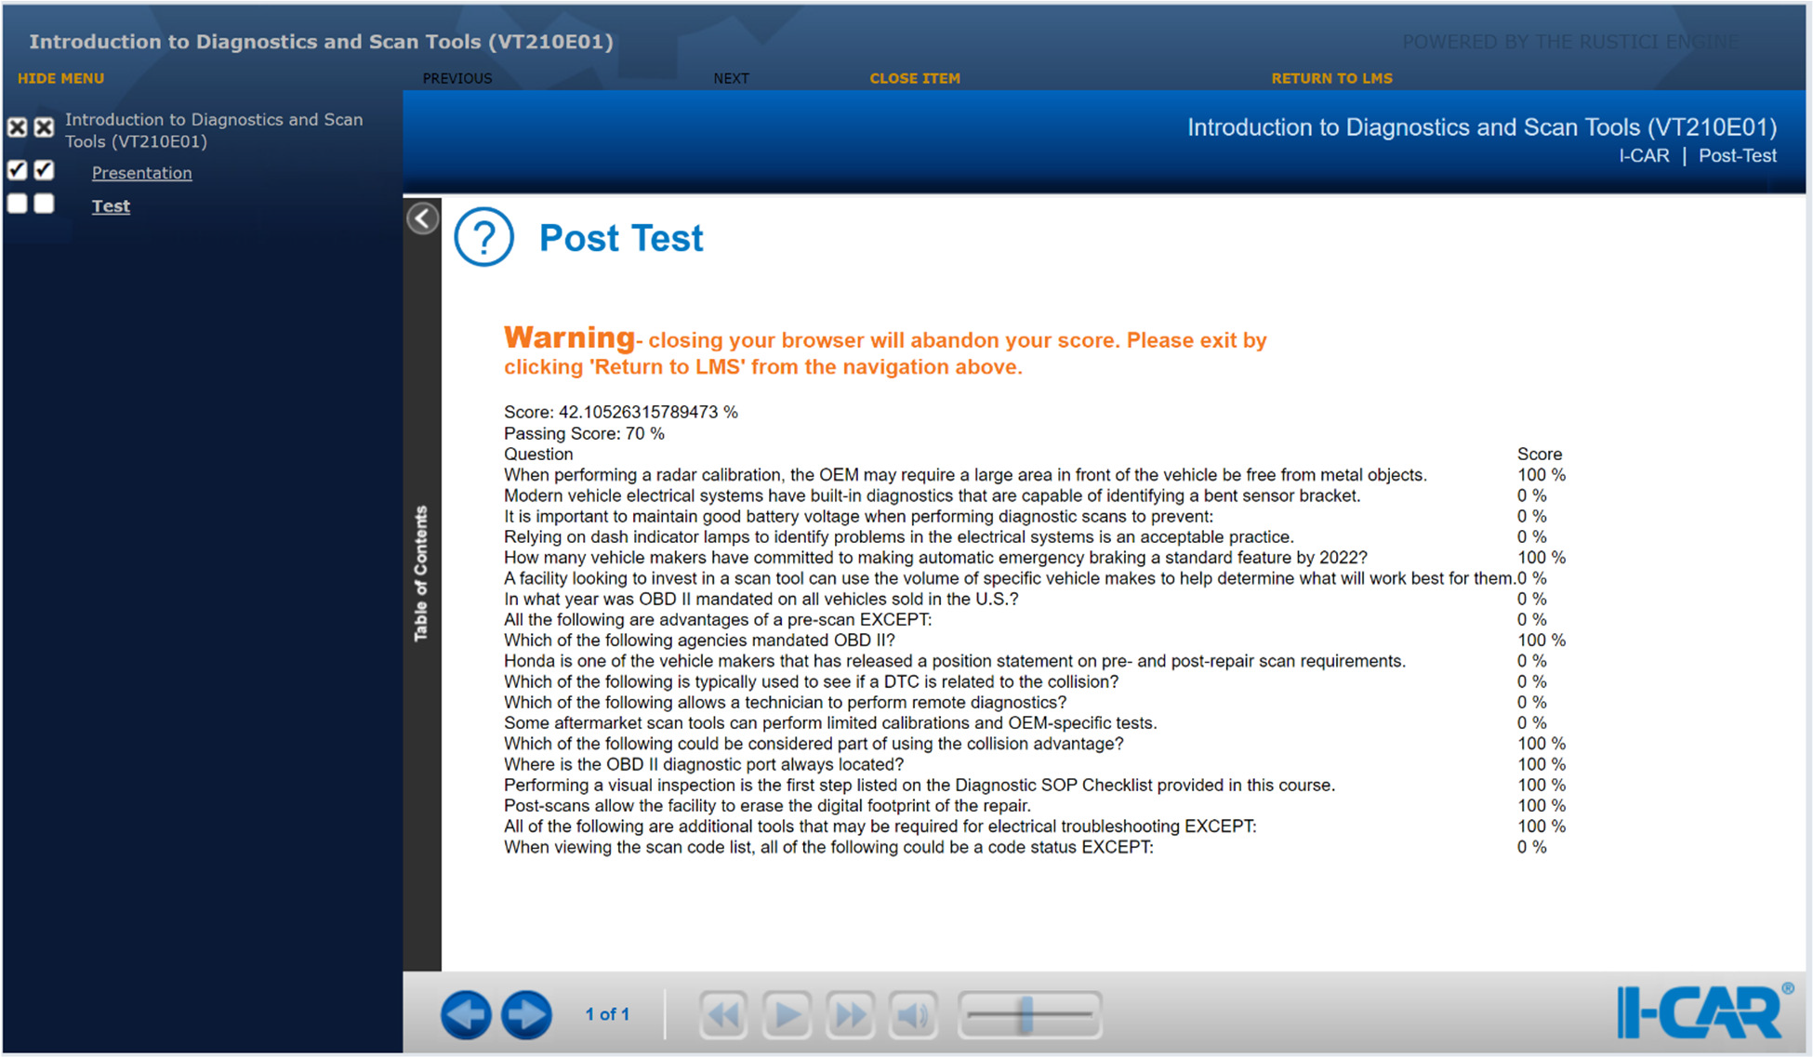

We also suggest that you take a screen shot/photo of this page for your records until results appear in your Dashboard.
To complete the course, select RETURN TO LMS at the top of the screen (highlighted orange in the image above) – this action will take you back to your myI-CAR Dashboard.
You will notice that the course is no longer in the Online Courses section but has now transferred to your Training History.
Please note: Your course results may take up to 72 hours to appear in your myI-CAR Dashboard.

If you have any additional enquiries regarding Online Training, please contact our office on 07-8470218 or email admin@i-car.co.nz.

